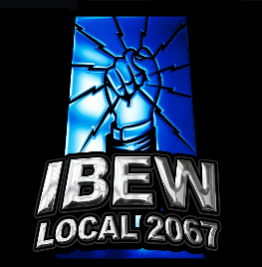
Dear IBEW Local 2067 Member,
In an effort to do things a little different this time, the Local is distributing this survey to better understand the priorities of the Members. By taking a few moments to fill out this survey, your bargaining committee can determine the issues and priorities that the membership would like to see addressed in negotiations. The results of this survey will be compiled and used to create a bargaining package that accurately reflects the membership’s needs.
In solidarity,
IBEW Local 2067 / SaskPower Bargaining Committee

- Do you consider the current health / dental benefits adequate? YES NO
If no, what would you like to see changed?

- Do you feel the current pension plan is adequate? YES NO

- Are you in favor of an annual percentage increase for all members? YES NO
If yes, what would you like to see?

- Rank, in order of importance to you the issues below #1 being your top priority, and #5 being your lowest.
BENEFITS _____
FLEX SPENDING ACCOUNT _____
VACATION _____
PENSION _____
WAGES (GENERAL WAGE INCREASE) _____

- How likely are you to look for another job if the contract does not meet your needs?
Very likely ____ likely ____ neutral ____ not likely ____ never ____

Name (optional) | Work Location | Classification

Thank you for taking to the time to participate in the survey. Any issues or comments on what you would like to see addressed, please use the space below and / or additional paper and submit along with your survey.

